Deploying Web Application Using Ansible
Description To create an automation script to deploy an application using Ansible
Tasks
The following tasks outline the process of deploying a web application.
- Create an project folder and Directory layout
- inventory file to define the local or remote server(s)
- Write a YAML playbook with tasks for installing Nginx, copying web application files, deploying the Nginx configuration.
- Create a directory for templates and an Ansible playbook for the Nginx configuration
- Define variables in the playbook for application details.
- Include tasks in the playbook for installing Nginx, copying application files, deploying Nginx configuration, and enabling the Nginx site
- Execute the playbook to deploy the web application on the local / remote server

Solution Steps Execute the playbook to deploy the web application on the local / remote server
- First Create a new project named Ansible-terraform-project with the directory structure

- Creat Role using the ansible-galaxy init webapp.

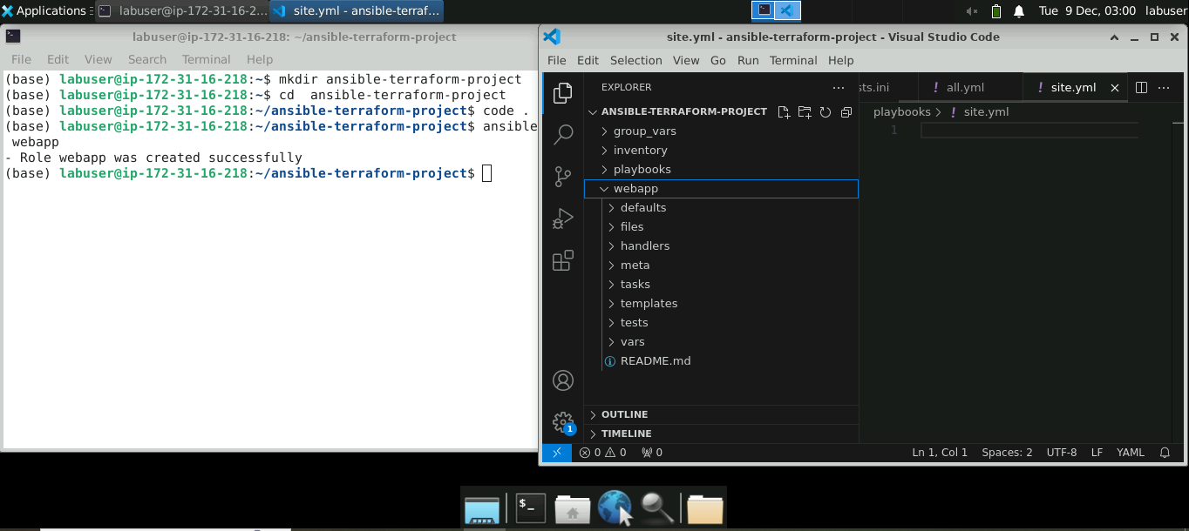

- ansible-inventory -i inventory/hosts.ini –list
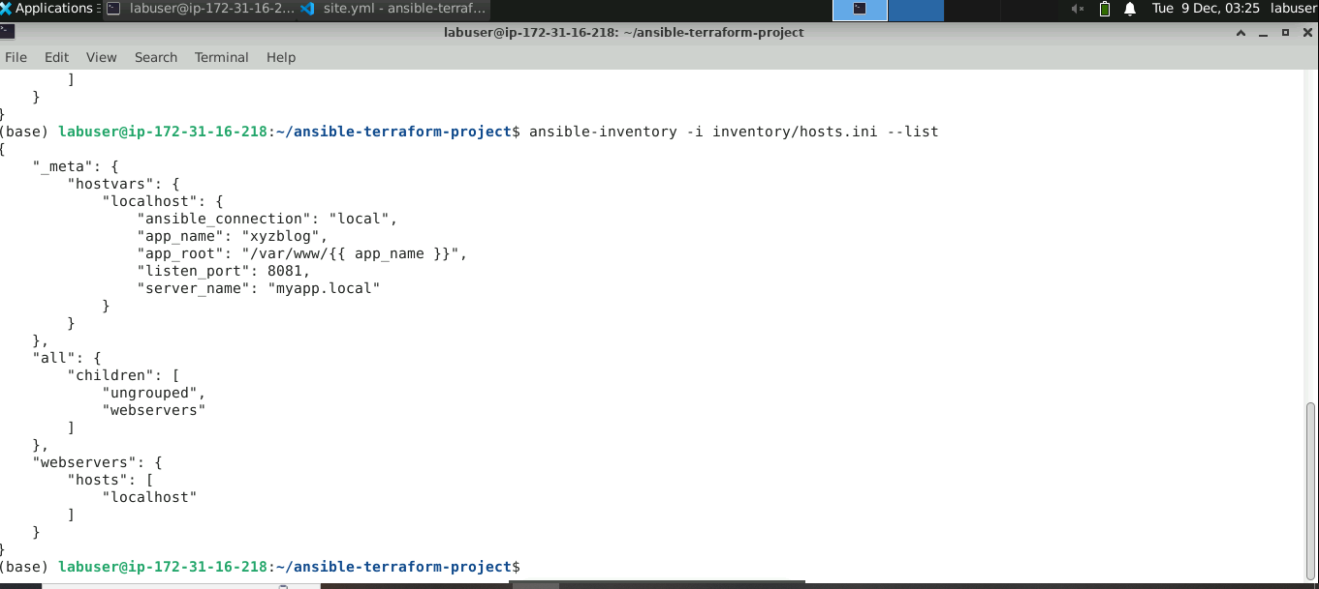

- ansible-playbook -i inventory/hosts.ini playbooks/site.yml –check
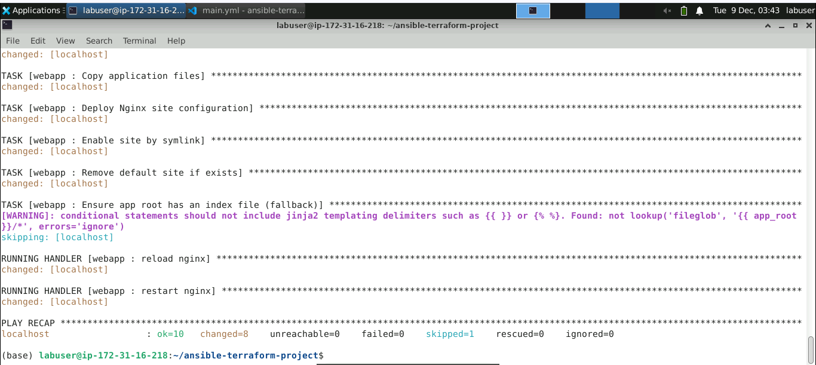

- ansible-playbook -i inventory/hosts.ini playbooks/site.yml

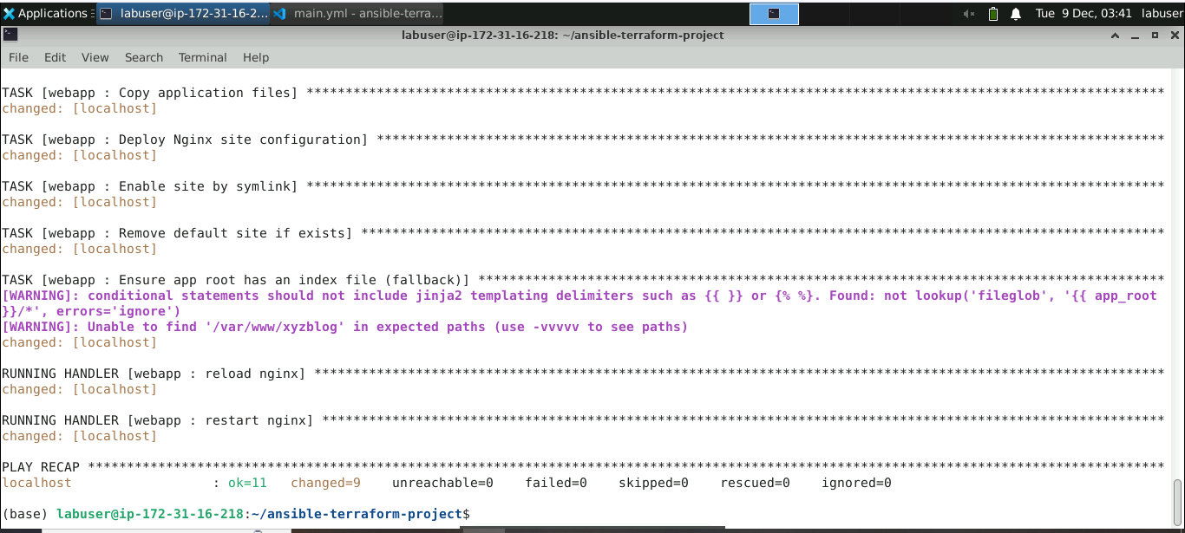
- sudo systemctl status nginx
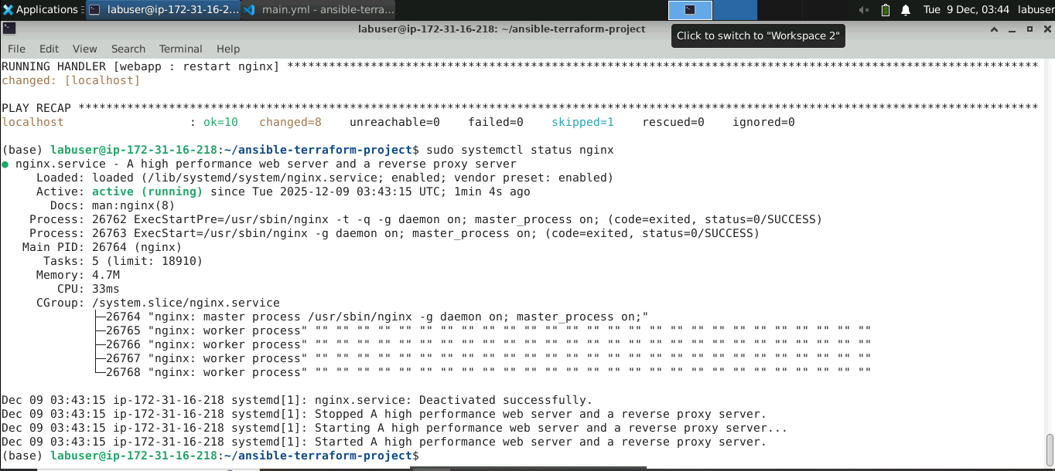
7